# Configure Service Response Caching

1. Go to Publisher Portal 🡪 APIs 🡪 Product Assets 🡪 Operations 🡪 getAssetsByGtin 🡪 Caching
2. Enable response caching for 2 minutes as shown below.

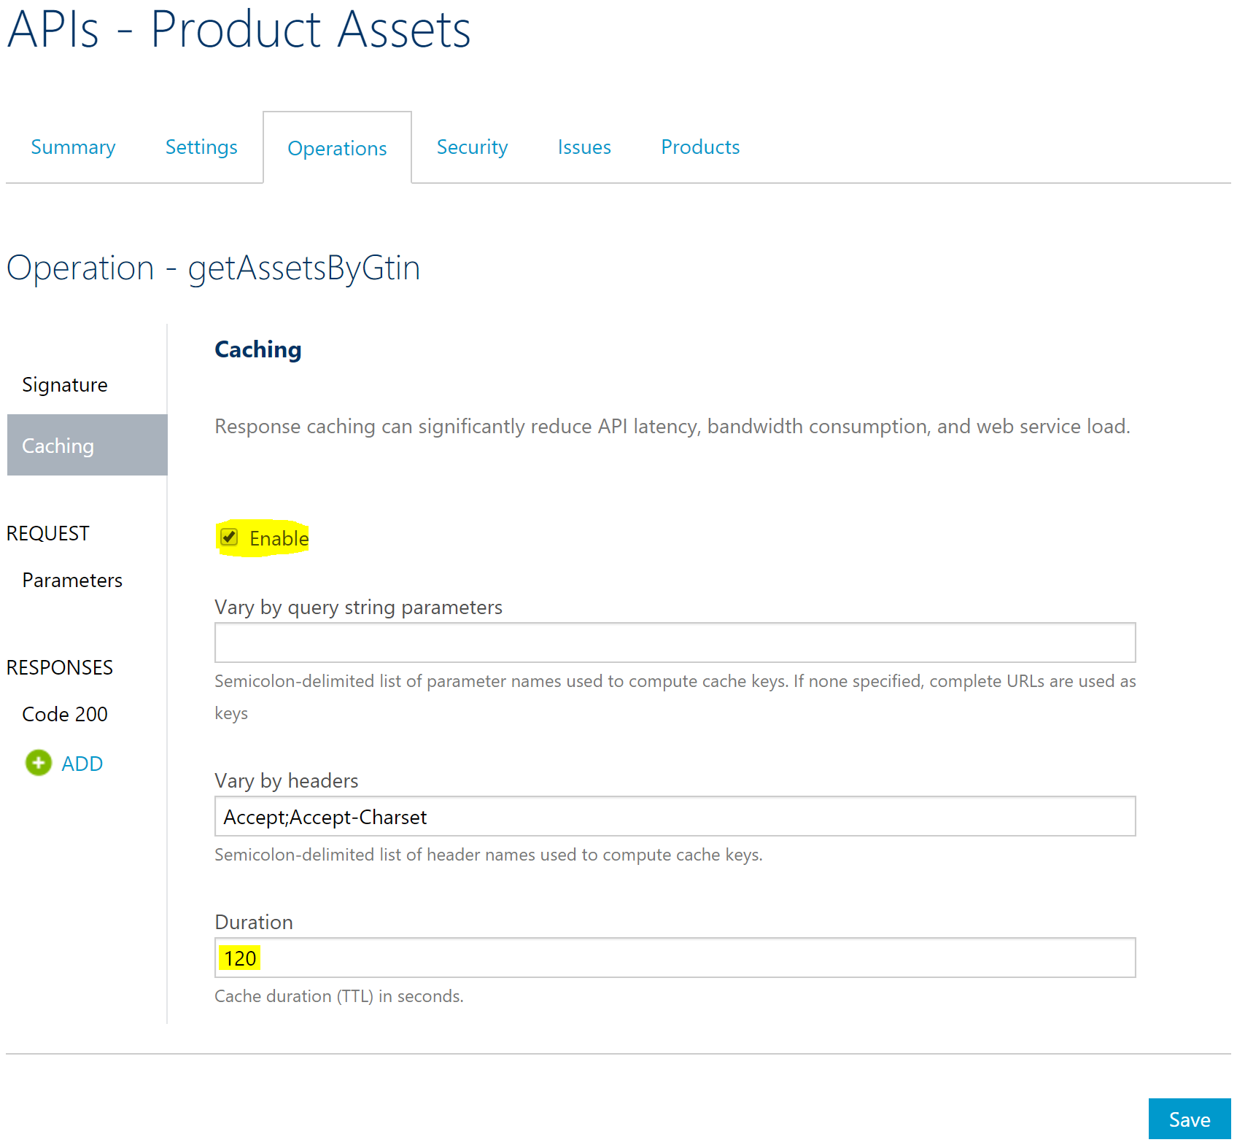

1. Access the Product Assets service (<https://pgecommerce.azure-api.net/dam/assets/47400656109>) and the aggregated Products service (<https://pgecommerce.azure-api.net/products/47400656109>). Look at the value of **assetsLastUpdatedAt** attribute.
2. Continue accessing the APIs within a span of 2 minutes and notice that the **assetsLastUpdatedAt** values does not change, indicating that the service response is being cached. After 2 minutes, the value gets updated indicating that cache has been updated with new service call result.

# CACHED RESULT WHEN SERVICE IS DOWN

1. In the Azure Portal, go ahead and stop Product Assets API App.
2. Access the Product Assets service (<https://pgecommerce.azure-api.net/dam/assets/47400656109>) and the aggregated Products service (<https://pgecommerce.azure-api.net/products/47400656109>). Note that the service and the corresponding HTML pages continue to function without any disruption for the cache duration configured.
3. **Ensure to restart the Product Assets API app for the remaining hands-on exercises.**

# References

* Basic response caching – <https://docs.microsoft.com/en-us/azure/api-management/api-management-howto-cache>
* Custom caching / fragment caching – <https://docs.microsoft.com/en-us/azure/api-management/api-management-sample-cache-by-key>
* Caching policies – <https://docs.microsoft.com/en-us/azure/api-management/api-management-caching-policies>